Sanima Capital

Sama Marga, Naxal, Kathmandu, Nepal

Meeting no:125

Meeting Date: August 19, 2025

Minute prepared by: Research Department

Discussion Topic: Meeting on Commercial Bank as of Q4

|  |  |  |  |
| --- | --- | --- | --- |
| Name | Signature | Attendance | Comment |
| Bhism Raj Chalise |  | Yes No  Noted |  |
| Poskar Basnet |  | Yes No  Noted |  |
| Akhilesh Bikram Sthapit |  | Yes No  Noted |  |
| Punya Ram Kasichhwa |  | Yes No  Noted |  |
| Dinesh Singh Mahat |  | Yes No  Noted |  |
| Pratistha Gautam |  | Yes No  Noted |  |
| Abin Neupane |  | Yes No  Noted |  |
| Anil Siwakoti |  | Yes No  Noted |  |
| Anup Acharya |  | Yes No  Noted |  |

**Seasonality of commercial bank**

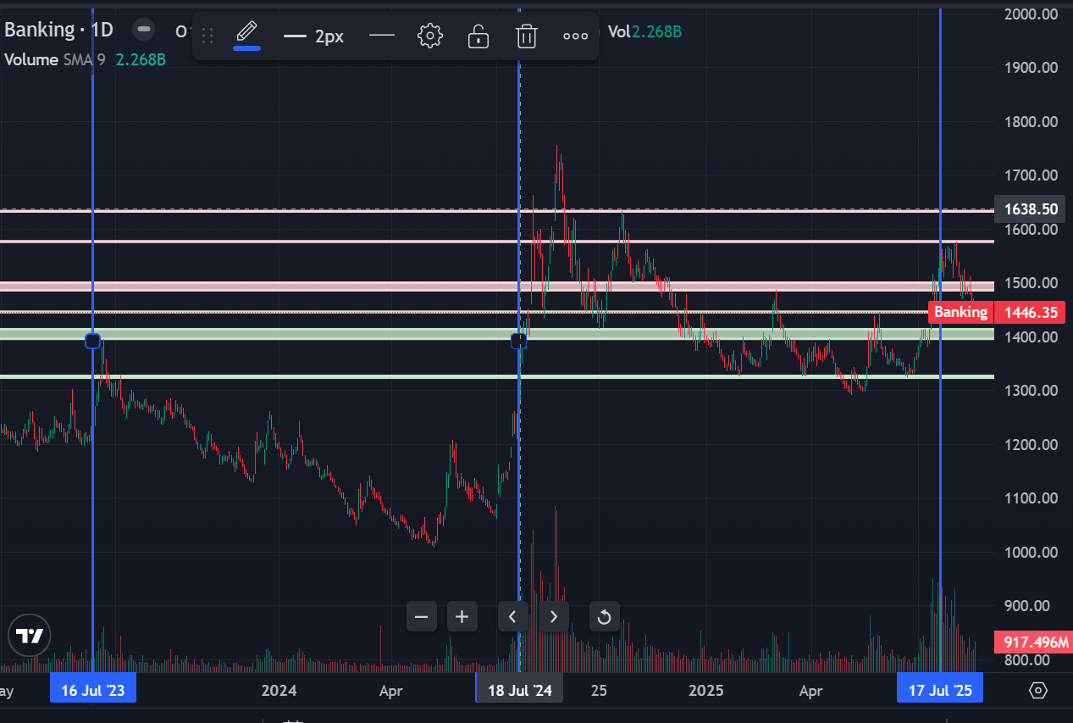

**Introduction**

The Nepali banking sector is showing concerning trends in asset quality, with a clear pattern of rising Non-Performing Loans (NPLs) across most institutions. The sector exhibits significant disparity in NPL management, the sector average has risen dramatically from 3.53% in 2023/24 Q3 to 4.25% in 2024/25 Q4. Some of the banks like LSL , ADBL SCB, and EBL is showing sine of decrease in the NPL

The banking industry's P/E and P/B ratios from 2014 to 2024 reflect evolving investor sentiment and valuation perspectives. The P/E ratio saw a sharp rise from 2014 to 2016, peaking at around 30, suggesting strong growth expectations. However, it declined steadily until 2019, indicating a shift to caution as growth prospects dimmed. data suggests banks remain relatively attractive on a valuation basis, particularly for investors seeking dividend yield and potential multiple expansion. However, the sustained low valuations also reflect structural challenges,

The chart illustrates the trends of the NEPSE index, the Banking index, and the P/E ratio of the banking sector from 2014/15 Q1 to 2024/25 Q4. The NEPSE and Banking indices exhibit similar trends, with the Banking index reflecting slightly less volatility. The fluctuating P/E ratio indicates changing market perceptions of the banking sector’s growth potential and risks. The current banking sector PE of approximately 15-20x represents a middle ground between historical peaks and troughs, suggesting neither extreme overvaluation nor undervaluation on a historical basis.

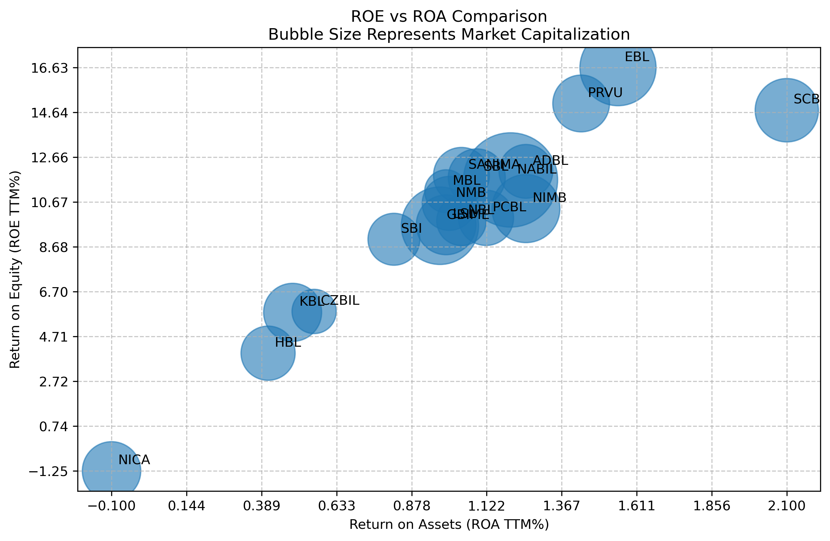

The bubble chart visualizes the relationship between Return on Equity (ROE)(TTM) and Return on Assets (ROA)(TTM) for various commercial banks, with bubble sizes representing market capitalization.   
The chart effectively highlights the varying levels of profitability and asset efficiency among commercial banks. SCB, ADBL, and EBL demonstrate high ROE and ROA values, reflecting strong profitability and efficient operations, making them attractive to investors. Conversely, banks like NICA, KBL HBL with low ROE and ROA may face challenges in improving profitability. This data helps in identifying banks that balance growth with profitability and those that might be undervalued or have potential for improvement.

**Debenture that has matured this year**

|  |  |  |  |  |  |  |
| --- | --- | --- | --- | --- | --- | --- |
| S.n. | Issuer | Ticker | coupon rate | maturity | subscribed amount | Par value |
| 1 | NICA | NICAD8182 | 7.25% | January 8, 2025 | 3,000,000,000 | 1,000 |

NICA has matured 7.25% bond with 3 billion and has been transferred to Capital Adjustment Reserve. As per the quarterly reports

**Debenture maturing in the next three years**

|  |  |  |  |  |  |  |
| --- | --- | --- | --- | --- | --- | --- |
| **Ticker** | **Issuer** | **coupon rate** | **Payment frequency** | **maturity** | **subscribed amount** | **Simple rating (SR)** |
| NICAD8283 | NICA | 11.00% | semiannual | 19-Sep-2025 | 1,830,000,000 | BBB+ |
| SBLD2082 | SBL | 10.50% | semiannual | 12-Jan-2026 | 2,162,559,000 | AA |
| NIBD2082 | NIMB | 10.50% | semiannual | 17-Jun-2026 | 2,000,000,000 | A |
| SBID83 | SBI | 10.25% | semiannual | 27-Jul-2026 | 2,401,482,000 | AA |
| HBLD83 | HBL | 10.00% | semiannual | 24-Aug-2026 | 3,000,000,000 | BBB+ |
| NICD83/84 | NICA | 10.25% | semiannual | 25-Aug-2026 | 1,943,698,000 | BBB+ |
| SBLD83 | SBL | 10.25% | semiannual | 10-Sep-2026 | 2,500,000,000 | AA |
| SRBLD83 | LSL | 10.25% | semiannual | 11-Dec-2026 | 3,000,000,000 | BBB+ |
| ADBLD83 | ADBL | 10.35% | semiannual | 8-Feb-2027 | 2,500,000,000 | A |
| ADBLB | ADBL | 4.00% | semiannual | 10-Feb-2027 | 6,000,000,000 | A |
| ICFCD83 | ICFC | 12.00% | semiannual | 10-Mar-2027 | 200,000,000 | BBB- |
| GWFD83 | GFCL | 12.00% | semiannual | 22-Mar-2027 | 250,000,000 | BB- |
| NBLD82 | NABIL | 10.00% | semiannual | 2-May-2027 | 2,000,000,000 | A |
| RBBD83 | RBB | 8.50% | semiannual | 16-Jun-2027 | 2,500,000,000 | A+ |
| PBD84 | PCBL | 10.15% | semiannual | 5-Jul-2027 | 5,000,000,000 | A- |
| SBLD84 | SBL | 8.50% | semiannual | 11-Oct-2027 | 3,000,000,000 | AA |
| SCBD | SCB | 10.30% | semiannual | 7-Feb-2028 | 2,400,000,000 | AAA |
| NIBD84 | NIMB | 8.50% | semiannual | 20-Feb-2028 | 4,000,000,000 | A |

NICA is maturing 11% also maturing in 2025 next fiscal year. SBL and NIB have issued bonds with a coupon rate of 10.50%, maturing in 2026.

As these debentures matured, there are high chances of to increase their dividend capacity as they do not have to transferred their portions of profits to the debenture redemption reserves.

**Dividend Capacity**

**Summary of the Report with relative valuation**

|  |  |  |  |  |  |  |  |  |
| --- | --- | --- | --- | --- | --- | --- | --- | --- |
| Abb | DDPS (total) (actual) | ICPS | EPS | BVPS | Price | Div Yield | PE | PV |
| EBL | 38.27 | (1.25) | 37.99 | 247.39 | 715.69 | 5.3% | 18.84 | 2.89 |
| ADBL | 20.77 | 0.77 | 29.98 | 243.40 | 332.45 | 6.2% | 11.09 | 1.37 |
| SANIMA | 20.47 | 13.91 | 18.93 | 168.83 | 367.83 | 5.6% | 19.43 | 2.18 |
| SCB | 19.85 | (3.35) | 30.17 | 216.96 | 637.46 | 3.1% | 21.13 | 2.94 |
| NABIL | 17.64 | 8.86 | 26.34 | 235.58 | 523.82 | 3.4% | 19.88 | 2.22 |
| PCBL | 14.33 | 7.32 | 20.74 | 173.72 | 250.74 | 5.7% | 12.09 | 1.44 |
| GBIME | 14.11 | 11.30 | 16.28 | 177.63 | 250.95 | 5.6% | 15.42 | 1.41 |
| SBL | 13.22 | 9.34 | 24.10 | 219.97 | 369.19 | 3.6% | 15.32 | 1.68 |
| LSL | 12.34 | 4.85 | 16.91 | 186.63 | 233.78 | 5.3% | 13.83 | 1.25 |
| SBI | 11.29 | 9.44 | 16.54 | 188.59 | 394.34 | 2.9% | 23.84 | 2.09 |
| NMB | 10.40 | 5.22 | 17.87 | 177.50 | 252.33 | 4.1% | 14.12 | 1.42 |
| MBL | 9.23 | 3.04 | 17.31 | 163.79 | 251.77 | 3.7% | 14.55 | 1.54 |
| CZBIL | 5.25 | 18.12 | 8.76 | 155.42 | 211.37 | 2.5% | 24.14 | 1.36 |
| PRVU | 4.44 | (10.67) | 23.12 | 162.00 | 218.42 | 2.0% | 9.45 | 1.35 |
| NIMB | 1.44 | 1.68 | 19.80 | 197.38 | 216.15 | 0.7% | 10.92 | 1.10 |
| NBL | (3.06) | 4.87 | 25.68 | 259.81 | 266.21 | -1.1% | 10.37 | 1.02 |
| KBL | (10.65) | 10.66 | 8.07 | 142.19 | 204.94 | -5.2% | 25.40 | 1.44 |
| HBL | (32.79) | 7.09 | 6.98 | 175.07 | 216.11 | -15.2% | 30.94 | 1.23 |
| NICA | (34.94) | 27.78 | 1.08 | 197.90 | 365.66 | -9.6% | 337.60 | 1.85 |

The table includes key financial metrics for each bank, such as impairment charge per share, Distributable Dividend per share (DDPS) as of Q4 and retained earnings, EPS as of Q4, book value per share (BVPS), Price, P/E ratio, and P/B ratio.

**Dividend Analysis:**

**High-Yield Leaders**: ADBL actually offers the highest sustainable yield at 6.2%, followed by PCBL (5.7%) and SANIMA/GBIME (both 5.6%). EBL, while having the highest absolute DDPS, only yields 5.3% due to its premium stock price.

**Negative Yield Situations**: Several banks show negative dividend yields, indicating they're not paying dividends . NBL (-1.1%), KBL (-5.2%), HBL (-15.2%), and NICA (-9.6%) represent will not be able to give divided this year

**Valuation Analysis**

This Q4 2024/25 valuation matrix reveals opportunities across the banking sector that warrant immediate portfolio repositioning.

**Extreme Value Opportunities**: PRVU stands out with a compelling 9.45x PE despite solid fundamentals (23.12 EPS, due to high writeback of impairment ), representing potential upside to sector median valuations only for the short run due to high write back. ADBL at 11.09x PE combined with strong dividend yield (6.2%) and minimal credit issues creates good valuation. These appear significantly undervalued relative to operational quality.

**Value Traps vs. Genuine Distress:** NBL (10.37x PE) and NIMB (10.92x PE) appear cheap but warrant caution given operational challenges as of very low or negative dividend yields. Conversely, PCBL at 12.09x PE with strong DDPS and moderate ICPS represents genuine value rather than a distressed situation.

**Removing one time impairment for analysis.**

|  |  |  |  |  |
| --- | --- | --- | --- | --- |
| Abb | ICPS | EPS | EPS without impairment | PE without impairment |
| EBL | (1.25) | 37.99 | 37.21 | 19.24 |
| ADBL | 0.77 | 29.98 | 30.47 | 10.91 |
| SANIMA | 13.91 | 18.93 | 27.69 | 13.28 |
| SCB | (3.35) | 30.17 | 28.06 | 22.72 |
| NABIL | 8.86 | 26.34 | 31.93 | 16.41 |
| PCBL | 7.32 | 20.74 | 25.35 | 9.89 |
| GBIME | 11.30 | 16.28 | 23.39 | 10.73 |
| SBL | 9.34 | 24.10 | 29.98 | 12.32 |
| LSL | 4.85 | 16.91 | 19.96 | 11.71 |
| SBI | 9.44 | 16.54 | 22.48 | 17.54 |
| NMB | 5.22 | 17.87 | 21.15 | 11.93 |
| MBL | 3.04 | 17.31 | 19.23 | 13.10 |
| CZBIL | 18.12 | 8.76 | 20.17 | 10.48 |
| PRVU | (10.67) | 23.12 | 16.40 | 13.32 |
| NIMB | 1.68 | 19.80 | 20.86 | 10.36 |
| NBL | 4.87 | 25.68 | 28.74 | 9.26 |
| KBL | 10.66 | 8.07 | 14.79 | 13.86 |
| HBL | 7.09 | 6.98 | 11.45 | 18.87 |
| NICA | 27.78 | 1.08 | 18.59 | 19.67 |

ICPS represents one-time provisioning rather than recurring operational issues. Stripping out impairment charges reveals the underlying earning power of these institutions. Looking at this PCBL and NBL seems better

**2 years Impairment charge MRQ**

|  |  |  |  |  |  |  |  |  |
| --- | --- | --- | --- | --- | --- | --- | --- | --- |
|  | 2024/25 | 2024/25 | 2024/25 | 2024/25 | 2023/24 | 2023/24 | 2023/24 | 2023/24 |
|  | Q4 | Q3 | Q2 | Q1 | Q4 | Q3 | Q2 | Q1 |
| GBIME | 1,195,278 | 906,385 | 1,131,972 | 1,071,776 | (1,521,324) | 1,128,607 | 2,354,246 | 1,781,772 |
| NICA | 1,094,286 | 690,595 | 1,195,336 | 1,164,337 | 695,795 | 1,668,493 | (164,269) | 644,307 |
| KBL | (2,370,931) | 1,894,031 | 2,642,453 | 630,689 | 20,593 | 777,608 | 582,937 | 2,183,140 |
| NABIL | 104,698 | 942,199 | 893,282 | 457,727 | (11,553) | 1,264,152 | 860,124 | 1,111,667 |
| HBL | 215,529 | 1,134,917 | 507,103 | (322,502) | 529,444 | 309,438 | 1,191,315 | 756,622 |
| CZBIL | 512,154 | 778,729 | 476,220 | 909,135 | 779,511 | 126,210 | 433,027 | 426,474 |
| SANIMA | 484,801 | 642,367 | 198,786 | 563,166 | (103,103) | 752,404 | 302,370 | 542,701 |
| SBI | 302,720 | 486,604 | 516,844 | (277,616) | (163,645) | 51,619 | 451,565 | 296,856 |
| PCBL | (912,093) | 1,470,059 | 451,074 | 410,456 | 348,826 | 613,912 | 64,463 | 216,649 |
| NMB | (335,013) | 948,330 | 381,804 | (37,039) | 1,117,615 | (154,139) | 477,432 | 480,169 |
| NBL | 852,780 | (2,244,624) | 1,838,950 | 688,492 | (1,063,401) | 1,582,816 | 735,475 | 1,341,793 |
| MBL | (361,914) | 510,982 | 248,119 | (43,416) | 127,885 | 705,726 | 226,299 | 12,290 |
| SBL | (901,094) | (48,691) | 1,260,132 | 1,005,014 | (478,233) | 525,857 | (249,499) | 1,433,563 |
| LSL | (2,018,279) | 1,269,270 | 761,264 | 1,167,991 | (582,605) | 1,269,042 | 586,088 | 2,146,521 |
| EBL | (434,670) | (76,650) | 242,894 | 106,704 | (354,782) | 204,841 | 2,843 | 429,502 |
| SCB | (237,241) | 151,760 | (193,583) | (57,198) | (33,933) | 198,651 | 31,131 | 20,265 |
| NIMB | (623,757) | (574,427) | 797,430 | 975,163 | 155,861 | 181,929 | 2,227,171 | 640,675 |
| ADBL | (810,598) | 59,317 | (44,757) | 902,261 | (288,748) | 425,853 | (1,063,571) | 2,160,076 |
| PRVU | (3,749,517) | 423,788 | 430,054 | 384,170 | (1,201,834) | 500,878 | 1,178,349 | 79,418 |

The table shows the impairment charge for the last two year Qtr on the qtr. Trend seen generally the impartment change is writeback in the last qtr.

**Analysis of NRB required Key indicators**

|  |  |  |  |  |  |  |  |  |  |
| --- | --- | --- | --- | --- | --- | --- | --- | --- | --- |
| Abb | Tire 1 RWA Q4 | Capital Fund to RWA | Non Performing Loan (NPL) to Total Loan | Total Loan Loss Provision to Total NPL | Credit Deposit Ratio as per NRB Calculations | Cost of Funds | Net Interest Spread | Base Rate | Base Rate - Cost of Fund |
| HBL | 8.79% | 11.64% | 7.28% | 107.10% | 81.35% | 4.84% | 3.29% | 6.63% | 1.79% |
| SBL | 9.88% | 11.77% | 2.62% | 124.30% | 76.92% | 4.39% | 3.98% | 6.42% | 2.03% |
| PCBL | 10.39% | 11.74% | 5.56% | 93.09% | 83.39% | 5.21% | 3.69% | 6.49% | 1.28% |
| NABIL | 9.86% | 11.94% | 4.27% | 108.60% | 82.48% | 4.41% | 3.57% | 5.83% | 1.42% |
| LSL | 10.09% | 12.73% | 4.25% | 110.21% | 77.15% | 4.47% | 3.51% | 6.50% | 2.03% |
| KBL | 8.94% | 12.98% | 6.42% | 138.43% | 75.73% | 4.74% | 3.59% | 6.44% | 1.70% |
| NMB | 9.22% | 12.03% | 3.72% | 101.14% | 84.33% | 5.06% | 3.82% | 6.22% | 1.16% |
| CZBIL | 9.08% | 12.45% | 4.94% | 105.98% | 81.84% | 4.49% | 3.99% | 8.26% | 3.77% |
| GBIME | 10.58% | 13.39% | 4.87% | 102.76% | 76.07% | 4.30% | 3.63% | 5.76% | 1.46% |
| SBI | 9.89% | 13.03% | 3.35% | 116.47% | 70.75% | 5.18% | 3.52% | 6.29% | 1.11% |
| EBL | 10.42% | 13.28% | 0.38% | 383.32% | 77.48% | 3.87% | 3.48% | 5.36% | 1.49% |
| MBL | 9.41% | 13.32% | 3.83% | 102.24% | 80.62% | 4.23% | 3.79% | 6.30% | 2.07% |
| PRVU | 10.19% | 13.90% | 4.96% | 126.65% | 70.78% | 4.36% | 3.73% | 6.67% | 2.31% |
| SANIMA | 9.86% | 13.01% | 3.01% | 121.80% | 81.03% | 4.70% | 3.68% | 6.12% | 1.42% |
| NBL | 10.05% | 13.06% | 4.47% | 114.80% | 70.72% | 3.74% | 3.90% | 5.58% | 1.84% |
| ADBL | 9.96% | 13.36% | 3.26% | 132.66% | 68.68% | 3.81% | 3.96% | 5.87% | 2.06% |
| NIMB | 11.93% | 13.73% | 5.85% | 108.87% | 74.44% | 4.25% | 3.01% | 5.78% | 1.53% |
| NICA | 8.87% | 14.00% | 6.28% | 92.01% | 73.97% | 4.92% | 3.99% | 7.04% | 2.12% |
| SCB | 15.80% | 17.82% | 1.47% | 160.08% | 69.48% | 3.22% | 3.53% | 4.99% | 1.77% |

This table provides insights into several key financial metrics for banks, including capital fund to RWA (Risk-Weighted Assets), non-performing loans (NPL) to total loan ratios, loan loss provisions, credit-deposit ratios, cost of funds, net interest spread, and base rates.

**Capital Adequacy**

* **Superior Capital Buffer**: SCB leads with exceptional capital fund to RWA ratio of 17.44%, far exceeding regulatory minimum. Will possible be cash divided.
* **At-Risk Position.** HBL, NICA, KBL is more on risk position due to lower tire 1 RWA ie 8.79%, 8.87%, 8.94%
* NIMB (11.93%), PCBL (10.39%), and GBIME (10.58%) maintain strong capital positions above 10% threshold
* EBL, LSL, and SBI cluster around 10.4-10.6%, representing adequate but not exceptional capital strength
* NICA, HBL and KBL Tire 1 capital adequacy although meeting the regulatory requirement may come in pressure if the asset quality decrease.

**Asset Quality Assessment:**

* EBL demonstrates exceptional credit management with 0.38% NPL ratio and 383.32% loan loss coverage
* SBI (2.62% NPL) and SANIMA (3.01% NPL) maintain acceptable asset quality standards
* Mid-tier performers include CZBIL (4.94%), GBIME (4.87%), and PRVU (4.96%) with manageable NPL levels
* HBL (7.28% NPL) ,NICA(6.28% NPL) (and KBL (6.42% NPL) face significant credit

**Liquidity Position:**

* ADBL demonstrates the strongest liquidity position at 68.68%, maintaining substantial deposit cushion for economic volatility and rapid loan growth opportunities
* SCB (69.48%), NBL (70.72%), SBI (70.75%), and PRVU (70.78%) form a conservative liquidity cluster with significant unutilized deposit capacity
* NICA (73.97%) and NIMB (74.44%) maintain prudent liquidity buffers while optimizing deposit deployment more aggressively than the ultra-conservative tier
* Mid-range deployment includes KBL (75.73%), GBIME (76.07%), SBL (76.92%), LSL (77.15%), and EBL (77.48%) - representing balanced liquidity management
* Aggressive liquidity utilization seen in MBL (80.62%), SANIMA (81.03%), HBL (81.35%), and CZBIL (81.84%) - approaching optimal deployment levels
* NABIL (82.48%), PCBL (83.39%), and NMB (84.33%) operate with the highest liquidity deployment, maximizing loan-to-deposit efficiency but with reduced flexibility in the current liquid market environment, higher CD ratios indicate superior performance

**Operational Efficiency (Base Rate - Cost of Funds):**

* SBI leads operational efficiency with exceptional 1.11% spread, demonstrating superior funding cost management and optimal asset-liability pricing
* NMB (1.16%) and PCBL (1.28%) achieve excellent efficiency metrics, indicating disciplined deposit pricing and effective rate management
* CZBIL's 3.77% represents poor operational efficiency, indicating either excessive deposit costs or inadequate lending rate optimization

**Base Rate Analysis**

* SCB achieves the strongest funding advantage at 4.99% base rate, indicating access to lowest-cost deposits and superior deposit franchise positioning
* EBL (5.36%) and NBL (5.58%) demonstrate excellent funding cost management, securing deposits at significantly below-market rates
* These lower base rate may create moat for banking sectors.

**Net Profit Comparison**

The chart presents a year-over-year (YOY) comparison of net profits for Q4 of the fiscal years 2023/24 and 2024/25 for various banks.

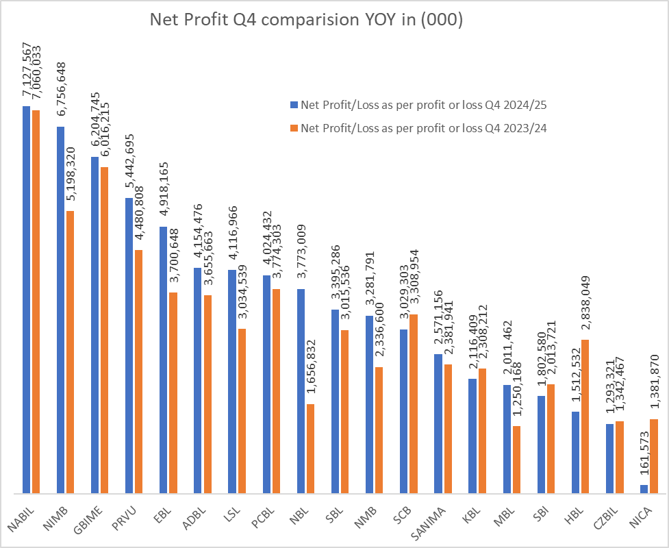

* NABIL achieves outstanding profit expansion from 7.06 b to 7.13 b, maintaining strong earnings momentum
* NIMB demonstrates robust growth from 5.20 b to 6.76 b, representing significant operational improvement
* GBIME shows solid earnings progression from 6.06 b to 6.20b, indicating consistent profit generation
* HBL profits collapse from 2.84b to 1.51b, confirming operational difficulties
* CZBIL faces substantial decline from 1.34b to 1.29b
* NICA shows catastrophic deterioration from 1.58 b to 16.1 cr, reflecting severe operational crisis

**Profitability Assessment:**

* NABIL, NIMB, and GBIME emerge as profit growth leaders with consistent YoY improvement
* Profit declines at SCB and several mid-tier banks suggest sector-wide margin pressure requiring strategic adjustments

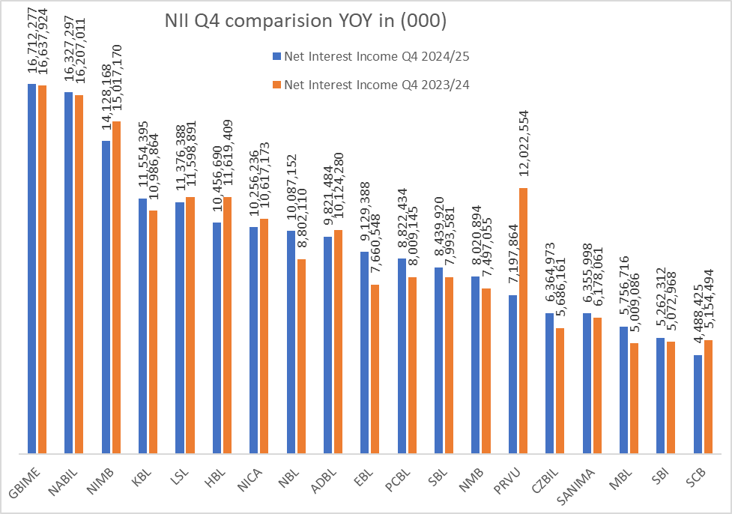

The chart compares the Net Interest Income (NII) for Q4 of the fiscal years 2023/24 and 2024/25 for various banks. This comparison indicates the varying performance of banks in leveraging their interest-earning assets, with some achieving notable growth while others face stagnation or limited increases in NII.

* Out of 19 listed commercial banks 12 have increased in NII and rest have decreased the NII.

**Analysis of Loans. Deposit Growth in Nepalese Banking Sector**

The chart compares the increase in loan and deposit amounts (in billions) for various banks between Q4 of 2023/24 and Q4 of 2024/25. It also shows the percentage growth for both loans and deposits over the year.

**Loan Growth**

* EBL, NMB , NBL and MBL growth leaders in loan. NICA, KBL and SCB have negative loan growth.

**Deposit Growth**

* EBL , NMB , PCBL, ADBL have high growth and NICA have negative growth

**Growth Deterioration:**

* NICA shows severe operational decline with -17.4% loan contraction and -10.0% deposit shrinkage, indicating fundamental business distress
* SCB faces concerning -1.1% loan decline despite positive 11.4% deposit growth, suggesting conservative lending or credit quality concerns
* KBL (-3.1% loans, 9.5% deposits) shows loan portfolio contraction while maintaining deposit growth
* HBL's minimal 0.2% loan growth with low 5.2% deposit growth indicates increase in the cost.

**Strategic Growth Implications:**

* EBL emerges as the clear growth champion with balanced 19.3% loan and 28.6% deposit expansion, supporting sustainable market share gains
* NICA requires attention given double-digit contractions in both core business lines
* Institutions with deposit growth exceeding loan growth (ADBL, SCB) may be building for future expansion or facing credit appetite constraints

This analysis underscores a mixed performance in the banking sector, with certain banks capitalizing on growth opportunities, while others face challenges in expanding their core lending and deposit base. These trends highlight the importance of effective liquidity and credit management to sustain profitability in a competitive environment

**Conclusion**

The analysis of Nepalese commercial banks for Q4 2024/25 reveals a sector undergoing a period of significant contrasts and challenges. While some banks demonstrate strong growth in core areas like Net Interest Income (NII), loans, and deposits, others are grappling with rising Non-Performing Loans (NPLs), reduced profitability, and operational inefficiencies. Current liquid market conditions favor institutions with higher credit-deposit ratios and aggressive loan deployment strategies.

EBL, ADBL is top performer ,

**Recommendation**

PCBL,NMB - Balanced growth story with higher CD ratio and good divided yield and operational efficiency :,

SBL- for the maturity of debenture in next three years and good dividend possibility. Hold for the long run

To Avoid:. NICA - Fundamental operational distress across all metrics. HBL - High funding costs, deteriorating profitability, elevated NPLs. CZBIL - Poor operational efficiency despite some growth metrics.

However, can look for mean reversion for the stocks banking stock if the stock is near 200 levels for HBL and KBL.

Historical dividend

|  |  |  |  |  |  |  |  |  |
| --- | --- | --- | --- | --- | --- | --- | --- | --- |
| Company Name | Bonus (%) 2077-78 | Cash (%) 2077-78 | Bonus (%) 2078-79 | Cash (%) 2078-79 | Bonus (%) 2079-80 | Cash (%) 2079-80 | Bonus (%) 2080-81 | Cash (%) 2080-81 |
| ADBL | 20.00 | 1.05 | 2.00 | 11.00 |  |  | 3.00 | 7.53 |
| CZBIL | 12.91 | 3.09 | - | 9.00 |  | 5.79 | 4.00 | 0.21 |
| EBL | 6.00 | 4.32 | 13.00 | 7.68 | 10.00 | 10.53 | 10.00 | 5.53 |
| GBIME | 10.00 | 3.50 | 3.00 | 10.60 | 1.00 | 8.00 | 5.50 | 0.00 |
| HBL | 21.38 | 4.62 | 8.00 | 11.11 |  |  |  |  |
| KBL | 6.00 | 2.67 | - | 12.50 |  |  |  |  |
| LSL |  |  |  |  | 7.00 | 0.37 | 5.00 | 0.26 |
| MBL | 13.30 | 0.70 |  |  | 13.30 | 0.70 |  |  |
| NABIL | 33.60 | 4.40 | 18.50 | 11.50 |  | 11.00 |  | 10.00 |
| NBL | 14.00 | 3.00 | 2.00 | 10.00 |  |  |  |  |
| NICA |  |  |  |  | 29.00 | 1.52 |  |  |
| NMB | 12.50 | 3.30 | - | 8.25 |  |  |  |  |
| PCBL | 16.00 | 0.63 | 4.00 | 4.95 |  |  | - | 5.00 |
| PRVU | 12.00 | 0.63 | 6.50 | 1.50 |  |  |  |  |
| SANIMA | 17.00 | 0.89 | 10.00 | 0.98 | 9.00 | 5.70 |  | 5.26 |
| SBI | 3.50 | 1.81 | 3.00 | 7.53 | 3.75 | 6.80 | 3.80 | 6.85 |
| SBL | 14.25 | 0.75 | 12.50 | 0.66 |  | 4.21 | - | 4.00 |
| SCB | 10.00 | 3.06 | - | 16.51 |  | 19.00 | 6.50 | 19.00 |